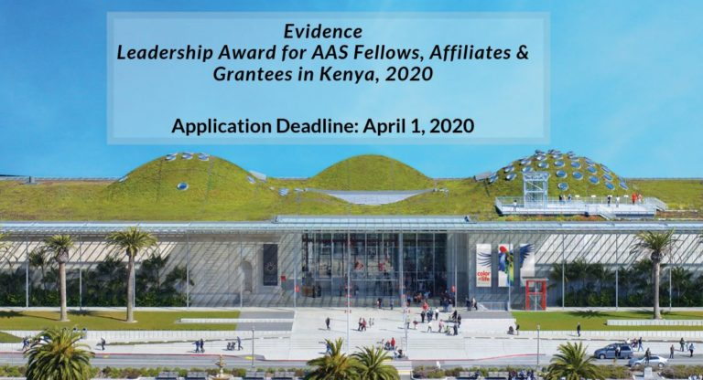

Evidence Leadership Award for AAS Fellows, Affiliates & Grantees in Kenya, 2020
The applications are open for AAS Fellows, Affiliates & Grantees to apply for the Evidence Leadership Award funded by the William and Flora Hewlett Foundation in Kenya.
This is designed for East and West African students who want to know the use of evidence in decision-making in government institutions to apply for a leadership award to recognize these efforts.
Established in 1985, the African Academy of Sciences is an Africa-wide scientific organization located in Nairobi, Kenya. It provides an efficient and effective implementation of policies and programmes throughout Africa.
Why should apply for this program? By joining the program, students will positively interact with employees or team members. They can easily overcome any current and future challenge easily.
Application Deadline: April 1, 2020

Brief Description
- University or Organization: The African Academy of Sciences
- Department: NA
- Course Level: Any
- Award: Up to US$ 5,000
- Access Mode: Online
- Number of Awards: Not known
- Nationality: East and West African students
- The award can be taken in Kenya

Eligibility
- Eligible Countries: Candidates from East and West African countries
- Acceptable Course or Subjects: The fellowship will be awarded in any subject.
- Admissible Criteria: To be eligible, the applicants must meet all the following criteria:
- Be an AAS fellow, grantee or affiliate.
- Be from one of the eligible countries in East and West Africa (East Africa: Burundi, Comoros, Djibouti, Eritrea, Ethiopia, Kenya, Rwanda, Seychelles, Somalia, Sudan, South Sudan, Tanzania, and Uganda. West Africa: Benin, Burkina Faso, Cape Verde, Côte d’Ivoire, The Gambia, Ghana, Guinea, Guinea-Bissau, Liberia, Mali, Niger, Nigeria, Senegal, Sierra Leone, and Togo).
- Be able to communicate in English or French.
- The awardee should also be able and available to travel to the July Evidence uptake conference in Nairobi.
- Provide at least 3 referees who will attest to their EIDM initiative(s) and its/their contribution to enabling evidence use. One of these referees must be a policymaker whom your work has benefited or impacted.

How to Apply
- How to Apply: In order to apply, applicants are required to downloading the application form and after completing the form they will submit via email to leadershipward@afidep.org
- Supporting Documents: Basic demographic information, name institutional affiliation and position held, short public biography of the applicant, CV, contact details of at least three referees, and a sample of any articles about your work related to EIDM.
- Admission Requirements: Applicants must have previous year degree from any recognized institution/university.
- Language Requirement: You should check all the English language requirements when you come to study at Melbourne Universit

Benefits:
The sponsorship will provide the following expenses:
- The award will have a monetary value of US$ 5,000 for the winner and US$ 2,500 for two runners-up. Winners will use the prize money to conduct evidence-to-policy activities with policymakers and researchers, for participation in relevant conferences, or to attend relevant professional development courses or programmes.
- The top winner will have an opportunity to speak at the evidence uptake conference that will be hosted in July 2020 in Nairobi for AAS scholars, researchers and policymakers. Expenses to the conference will be fully covered including conference registration, return economy flights, accommodation, and a modest stipend.

