|  |  |  |  |  |
| --- | --- | --- | --- | --- |
| |  |  |  |  | | --- | --- | --- | --- | | **SCHOLARSHIP OPPORTUNITIES**   |  |  |  | | --- | --- | --- | | |  |  | | --- | --- | | |  | | --- | |  | |   [**Harvard University Center for the Environment Fellowships for International Students in USA, 2018**](http://scholarship-positions.com/environmental-fellows-program/2016/11/19/)  Harvard University Center for the Environment, United States of America Application Deadline: January 17, 2018 [**Apply Now**](http://scholarship-positions.com/environmental-fellows-program/2016/11/19/)  [**Scholarships for Developing Countries at University of Reading in UK, 2018**](http://scholarship-positions.com/scholarships-for-developing-countries-university-reading-uk/2016/11/12/) University of Reading, United Kingdom Application Deadline: January 30, 2018 [**Apply Now**](http://scholarship-positions.com/scholarships-for-developing-countries-university-reading-uk/2016/11/12/)  [**Fully-Funded University of Oulu Masters Degree Scholarships for International Students Finland, 2018-2019**](http://scholarship-positions.com/duniversity-oulu-international-masters-scholarship-scheme-finland/2016/12/08/) University of Oulu, Finland Application Deadline: January 24, 2018 [**Apply Now**](http://scholarship-positions.com/duniversity-oulu-international-masters-scholarship-scheme-finland/2016/12/08/)  [**University of Tsukuba Masters Scholarship Program in Economic and Public Policy (PEPP) in Japan, 2018**](http://scholarship-positions.com/university-tsukuba-masters-scholarship/2016/11/19/) University of Tsukuba, Japan Application Deadline: February 28, 2018 [**Apply Now**](http://scholarship-positions.com/university-tsukuba-masters-scholarship/2016/11/19/)  [**The Centre of African Studies Visiting Fellowship at University of Cambridge in UK, 2018-2019**](http://scholarship-positions.com/the-centre-of-african-studies-visiting-fellowship-at-university-of-cambridge-in-uk-2017-2018/2016/11/12/) University of Cambridge, United Kingdom Application Deadline: January 15, 2018 [**Apply Now**](http://scholarship-positions.com/the-centre-of-african-studies-visiting-fellowship-at-university-of-cambridge-in-uk-2017-2018/2016/11/12/)  [**Giessen University PhD Scholarships for International Students in Germany, 2018-2019**](http://scholarship-positions.com/giessen-university-13-phd-scholarships-germany/2016/11/19/) Giessen University co-funded by the German federal government’s Excellence Initiative Application Deadline: February 1, 2018 [**Apply Now**](http://scholarship-positions.com/giessen-university-13-phd-scholarships-germany/2016/11/19/)  [**Dietrich School Diversity Postdoctoral International Fellowships in USA, 2018**](http://scholarship-positions.com/dietrich-school-diversity-postdoctoral-international-fellowships-usa/2017/11/18/) University of Pittsburgh, United States of America Application Deadline: February 16, 2018 [**Apply Now**](http://scholarship-positions.com/dietrich-school-diversity-postdoctoral-international-fellowships-usa/2017/11/18/)  [**ORMS Scholarships for Photographic Program for International Students in South Africa, 2018**](http://scholarship-positions.com/orms-scholarships-photographic-international-students-south-africa/2017/11/18/) Orms Cape Town School of Photography, South Africa Application Deadline: December 10, 2017 [**Apply Now**](http://scholarship-positions.com/orms-scholarships-photographic-international-students-south-africa/2017/11/18/)  [**Full Tuition Master Scholarships for International Students at University of Jyvaskyla in Finland, 2018**](http://scholarship-positions.com/full-tuition-master-scholarships-international-students-university-jyvaskyla-finland/2017/11/18/) University of Jyvaskyla, Finland Application Deadline: January 10, 2018 [**Apply Now**](http://scholarship-positions.com/full-tuition-master-scholarships-international-students-university-jyvaskyla-finland/2017/11/18/)  [**IWMF African Great Lakes Reporting Journalism Fellowship in South Sudan and Uganda, 2018**](http://scholarship-positions.com/iwmf-african-great-lakes-reporting-journalism-fellowship-south-sudan-uganda/2017/11/18/) International Women's Media Foundation Application Deadline: December 5, 2017 [**Apply Now**](http://scholarship-positions.com/iwmf-african-great-lakes-reporting-journalism-fellowship-south-sudan-uganda/2017/11/18/)  [**SRM University Scholarships for Indian Students, 2018**](http://scholarship-positions.com/srm-scholarships-for-indian-students/2017/11/18/) SRM University, India Application Deadline: March 31, 2018 [**Apply Now**](http://scholarship-positions.com/srm-scholarships-for-indian-students/2017/11/18/)  [**36 INPhINIT, ”la Caixa” Doctoral Fellowships for International Researchers in Spain, 2018**](http://scholarship-positions.com/inphinit-la-caixa-doctoral-fellowship-programme-international-reseachers-spain/2017/11/18/) Institute of Science of Materials of Barcelona, Spain Application Deadline: February 1, 2018 [**Apply Now**](http://scholarship-positions.com/inphinit-la-caixa-doctoral-fellowship-programme-international-reseachers-spain/2017/11/18/)  [**BIH Visiting Research Fellowships for International Applicants at Birkbeck, University of London in UK, 2018/19**](http://scholarship-positions.com/bih-visiting-research-fellowships-for-international-applicants-in-uk-2018-2019/2017/11/18/) Birkbeck, University of London, United Kingdom Application Deadline: May 21, 2018 [**Apply Now**](http://scholarship-positions.com/bih-visiting-research-fellowships-for-international-applicants-in-uk-2018-2019/2017/11/18/)  [**Henry Chauncey Jr. Postdoctoral Fellowships for International Scholars at Yale University in USA, 2018**](http://scholarship-positions.com/henry-chauncey-jr-postdoctoral-fellowships-for-international-scholars-yale-university-usa/2017/11/18/) Yale University, United States of America Application Deadline: February 15, 2018 [**Apply Now**](http://scholarship-positions.com/henry-chauncey-jr-postdoctoral-fellowships-for-international-scholars-yale-university-usa/2017/11/18/)  [**Lappeenranta University of Technology Master Scholarship for International Students in Finland, 2018**](http://scholarship-positions.com/lappeenranta-university-technology-master-scholarship-international-students-finland/2017/11/17/) Lappeenranta University of Technology, Finland Application Deadline: January 24, 2018 [**Apply Now**](http://scholarship-positions.com/lappeenranta-university-technology-master-scholarship-international-students-finland/2017/11/17/)  [**Regents’ and Chancellor’s Scholarship for International Students in USA, 2018**](http://scholarship-positions.com/regents-chancellors-scholarship-international-students-usa/2017/11/17/) University of California, USA Application Deadline: March 2 [**Apply Now**](http://scholarship-positions.com/regents-chancellors-scholarship-international-students-usa/2017/11/17/)  [**ANU Deep Human History Laureate PhD Scholarships for International Students in Australia, 2018**](http://scholarship-positions.com/anu-deep-human-history-laureate-phd-scholarships-international-students-australia/2017/11/17/) Australian National University Application Deadline: October 31, 2018 and November 13, 2018 [**Apply Now**](http://scholarship-positions.com/anu-deep-human-history-laureate-phd-scholarships-international-students-australia/2017/11/17/)  [**The RBC Black History Month Student Essay Competition in Canada, 2018**](http://scholarship-positions.com/rbc-black-history-month-student-essay-competition-canada/2017/11/17/) Royal Bank of Canada Application Deadline: December 1, 2017 [**Apply Now**](http://scholarship-positions.com/rbc-black-history-month-student-essay-competition-canada/2017/11/17/)  [**Fully Funded PhD Scholarships in Political Science at Trinity College Dublin in Ireland, 2018-2019**](http://scholarship-positions.com/fully-funded-scholarships-phd-study-political-science-trinity-college-dublin-ireland/2017/11/17/) Trinity College Dublin, Ireland Application Deadline: March 2018 [**Apply Now**](http://scholarship-positions.com/fully-funded-scholarships-phd-study-political-science-trinity-college-dublin-ireland/2017/11/17/) | | |

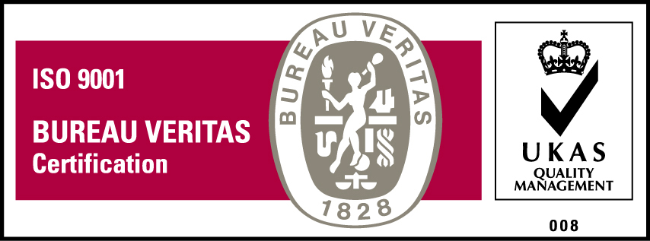***KyU is ISO 9001:2015 Certified***