Japanese Government (MEXT) Scholarships for Foreign Research Students in Japan, 2018
The Ministry of Education, Culture, Sports, Science and Technology (MEXT), Japan
Application Deadline: Various
Apply Now
30 Masters Scholarships at Participating Universities in China, 2018
Asia-Pacific Network for Sustainable Forest Management and Rehabilitation (APFNet), China
Application Deadline: May 31, 2018
Apply Now
King’s College London Dr Antony Kidman Scholarship in UK, 2018-2019
King’s College London, United Kingdom
Application Deadline: June 30, 2018
Apply Now
USTB Excellent Freshmen Scholarships for International Students in China, 2018
University of Science and Technology Beijing, China
Application Deadline: June 15, 2018
Apply Now
University of Winnipeg President Scholarship for World Leaders in Canada, 2018-2019
University of Winnipeg, Canada
Application Deadline: June 1, 2018 for Fall 2018 and October 1, 2018 for Winter 2019
Apply Now
OWSD Postgraduate Training Fellowships for Women from Developing Countries, 2018
Swedish International Development Cooperation Agency (Sida) and OWSD
Application Deadline: June 1, 2018
Apply Now
Kyushu University Friendship Scholarship Scheme in Japan, 2018
Kyushu University, Japan
Application Deadline: May 31, 2018
Apply Now
Carlo Cattaneo University-LIUC PhD Scholarships for International Students in Italy, 2018-2019
Carlo Cattaneo University-LIUC, Italy
Application Deadline: May 30, 2018
Apply Now
Victoria University of Wellington Graduate Award in New Zealand, 2018
Victoria University of Wellington, New Zealand
Application Deadline: November 1, 2018
Apply Now
Nagao Natural Environment Foundation Research Grant Programme for Asia-Pacific Region, 2018
Nagao Natural Environment Foundation
Application Deadline: October 16, 2018
Apply Now
Singapore Institute of Management GE Diploma Scholarship for International Students in Singapore, 2018
Singapore Institute of Management
Application Deadline: June 30, 2018
Apply Now
Manchester Writing School MA Scholarship in UK, 2018
Manchester Metropolitan University, United Kingdom
Application Deadline: August 31, 2018
Apply Now
University of Stirling Karen Napier Scholarship for MSc Investment Analysis in UK, 2018
University of Stirling
Application Deadline: May 31, 2018
Apply Now
Nigerian Stock Exchange Graduate Trainee Programme for Young Nigerians, 2018
The Nigerian Stock Exchange
Application Deadline May 21, 2018
Apply Now
Erasmus+: Erasmus Mundus Joint Master Degree (EMJMD) Scholarships in Nuclear Physics, 2018
Erasmus Mundus Joint Master Degree (EMJMD) in Nuclear Physics
Application Deadline: May 20 , 2018
Apply Now
ICFO International Postdoctoral Position in Topological Nano-Photonics in Spain, 2018
ICFO, Spain
Application Deadline: Open until positions are filled.
Apply Now
CBS PhD Scholarship within the Topic of Inequality for International Students in Denmark, 2018
Copenhagen Business School, Denmark
Application Deadline: June 8, 2018
Apply Now
RBC Capital Markets Scholarships in Canada, 2018
RBC Capital Markets, Canada
Application Deadline: May 31, 2018
Apply Now
AVENUE Scholarship Program in France, 2018-2019
French Embassy and the French institute in collaboration with Diálogo, the Spanish-French Friendship Association, and French and Spanish companies
Application Deadline: May 27, 2018
Apply Now
600 Suba Pathum Scholarships for Sri Lankan Students, 2018
Sri Lanka Insurance Corporation Limited
Application Deadline: May 31, 2018
Apply Now
AIFMRM Postdoctoral Research Fellowships at University of Cape Town in South Africa, 2018
University of Cape Town, South Africa
Application Deadline: May 31, 2018
Apply Now
Fully Funded MA Scholarships in Theology, Philosophy, Music at DCU in Ireland, 2018
Dublin City University, Ireland
Application Deadline: June 25, 2018
Apply Now
Constantina Maxwell Faculty MPhil Studentship for EU and Non-EU Students in Ireland, 2018/19
Trinity College Dublin, Ireland
Application Deadline: August 1, 2018
Apply Now
MBA Emerging Economies Leader for Social Change Scholarship at University of Stirling in UK, 2018
University of Stirling, United Kingdom
Application Deadline: May 31, 2018
Apply Now
Afghan Students Scholarships at American University of Central Asia in Kyrgyzstan, 2018
American University of Central Asia, Kyrgyzstan
Application Deadline: May 20, 2018
Apply Now
International Undergraduate Scholarships at Ulster University in Ireland, 2018
Ulster University, Ireland
Application Deadline: Applications are open for the year 2018
Apply Now
IILM Scholarship Scheme for PGDM in India, 2018-2020
IILM Institute for Higher Education, India
Application Deadline: Open
Apply Now
UNSW Art & Design International Scholarships in Australia, 2018
UNSW Art & Design, Australia
Application Deadline: October 31, 2018
Apply Now
20 Add-On Fellowships for Interdisciplinary Life Science at Joachim Herz Stiftung in Germany, 2018
Joachim Herz Stiftung in Germany
Application Deadline: July 18, 2018
Apply Now
Asia Pacific Social Impact Centre Social Enterprise Scholarships in Australia, 2018
Melbourne Business School, Australia
Application Deadline: June 4, 2018
Apply Now
OAS-Western University Undergraduate and Graduate Scholarships in Canada, 2018
Organization of American States
Application Deadline: May 30, 2018
Apply Now
Composition and Doctorate (PhD) Scholarships in Germany, 2018
Hochschule für Musik und Theater Hamburg, Germany
Application Deadline: May 25, 2018
Apply Now
Sustainable Cities Scholarship for UK/EU and International Students in UK, 2018
University of Leeds, United Kingdom
Application Deadline: May 31, 2018
Apply Now
BofAML Global Banking & Markets Internship Program for South Africans, 2018/19
Bank of America Merrill Lynch (BofAML)
Application Deadline June 30, 2018
Apply Now
NIKE Internship in Merchandising Category for International Students in Netherlands, 2018
NIKE
Application Deadline May 21, 2018
Apply Now
CERN Short-Term Internship Programme in Switzerland, 2018
CERN
Application Deadline December 12, 2018
Apply Now
Jones & Wagener Bursary Scheme in South Africa, 2019
Jones & Wagener
Application Deadline: July 31, 2018
Apply Now
Nova Southeastern University Scholarships for International Students in USA, 2018
Nova Southeastern University, USA
Application Deadline: May 29, 2018
Inquire Now
Duke University Free Online Course on English Composition
Duke University and Coursera
Course Starts on May 21, 2018
Apply Now
Free Online Course on Customer Relationship Management
Indian Institute of Management, Bangalore
Course Starts on June 7, 2018
Apply Now
People Management Online Course by IIM
Indian Institute of Management, Bangalore
Course Starts on July 5, 2018
Apply Now
Free Online Course on Sustainable Soil Management
Wageningen University & Research
Course Starts on August 28, 2018
Apply Now

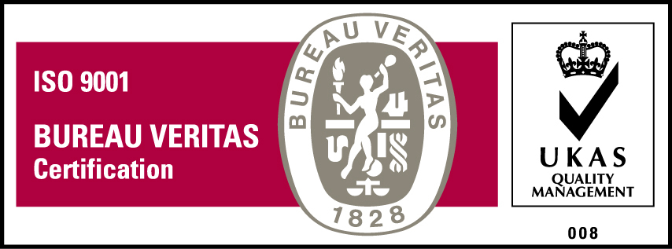
KyU is ISO 9001:2015 Certified

