|  |  |  |
| --- | --- | --- |
| |  |  | | --- | --- | | **SCHOLARSHIP OPPORTUNITIES**   |  | | --- | | [**Eiffel Scholarships for International Students in France, 2018**](http://scholarship-positions.com/eiffel-scholarships-for-international-students-201314-france/2012/10/03/) **French Government Scholarships** by the French Ministry of Foreign and European Affairs Application Deadline: January 12, 2018 [**Apply Now**](http://scholarship-positions.com/eiffel-scholarships-for-international-students-201314-france/2012/10/03/)  [**Undergraduate Scholars Entrance Scholarships at Simon Fraser University in Canada, 2018**](http://scholarship-positions.com/undergraduate-scholars-entrance-scholarships-simon-fraser-university-canada-2018/2017/10/28/) Simon Fraser University, Canada Application Deadline: February 15, 2018 [**Apply Now**](http://scholarship-positions.com/undergraduate-scholars-entrance-scholarships-simon-fraser-university-canada-2018/2017/10/28/)  [**European Commission Masters Scholarship for International Students in DCLead, 2018**](http://scholarship-positions.com/masters-scholarship-international-students-dclead/2017/10/28/) DCLead Application Deadline: December 1, 2017 [**Apply Now**](http://scholarship-positions.com/masters-scholarship-international-students-dclead/2017/10/28/)  [**University of British Columbia International Undergraduate Awards in Canada, 2018**](http://scholarship-positions.com/ubc-undergraduate-awards-international-students-canada/2016/09/08/) University of British Columbia in Canada Application Deadline: December 1, 2017 [**Apply Now**](http://scholarship-positions.com/ubc-undergraduate-awards-international-students-canada/2016/09/08/)  [**Friedrich Miescher Institute International PhD Program in Switzerland, 2018**](http://scholarship-positions.com/fmi-international-phd-program-switzerland-2014/2013/08/31/) Friedrich Miescher Institute for Biomedical Research (FMI), Switzerland Application Deadline: November 20, 2017 **Apply Now**  [**Adelaide Scholarships International (ASI) in Australia, 2018**](http://scholarship-positions.com/adelaide-scholarships-international-asi-overseas-applicants-australia-2014/2013/09/25/) University of Adelaide, Australia Application Deadline: January 31, 2018 [**Apply Now**](http://scholarship-positions.com/adelaide-scholarships-international-asi-overseas-applicants-australia-2014/2013/09/25/)  [**Ghent University Scholarships for Developing Countries in Belgium, 2018**](http://scholarship-positions.com/ghent-university-scholarships/2017/01/17/) Ghent University, Belgium Application Deadline: March 6, 2018 [**Apply Now**](http://scholarship-positions.com/ghent-university-scholarships/2017/01/17/)  [**Fully Funded International PhD and Postdoctoral Positions at University of Copenhagen in Denmark, 2018**](http://scholarship-positions.com/fully-funded-international-phd-postdoctoral-positions-university-of-copenhagen-denmark/2017/10/28/) University of Copenhagen, Denmark Application Deadline: December 1, 2017 [**Apply Now**](http://scholarship-positions.com/fully-funded-international-phd-postdoctoral-positions-university-of-copenhagen-denmark/2017/10/28/)  [**Chevening Clore Fellowship for Mid-career Professionals in UK, 2018**](http://scholarship-positions.com/cheveningclore-fellowship-mid-career-professionals-uk-2016/2015/09/21/) UK Foreign and Commonwealth Office Application Deadline: November 7, 2017 [**Apply Now**](http://scholarship-positions.com/cheveningclore-fellowship-mid-career-professionals-uk-2016/2015/09/21/)  [**Four-Year Wellcome Trust PhD Studentships for International Students at University of Sheffield in UK, 2018**](http://scholarship-positions.com/four-year-wellcome-trust-phd-studentships-international-students-university-sheffield-uk/2017/10/27/) University of Sheffield, United Kingdom Application Deadline: December 11, 2017 [**Apply Now**](http://scholarship-positions.com/four-year-wellcome-trust-phd-studentships-international-students-university-sheffield-uk/2017/10/27/)  [**GDAI PhD Scholarship for African Students at SOAS in UK, 2018**](http://scholarship-positions.com/gdai-phd-scholarships-african-students-soas-uk/2015/11/03/) The Mo Ibrahim Foundation, United Kingdom Application Deadline: March 31, 2018 [**Apply Now**](http://scholarship-positions.com/gdai-phd-scholarships-african-students-soas-uk/2015/11/03/)  [**Freigeist Fellowships for International Researchers in Germany, 2018**](http://scholarship-positions.com/volkswagen-foundation-freigeist-fellowships-germany/2017/01/19/) Volkswagen Foundation, Germany Application Deadline: October 12, 2018 [**Apply Now**](http://scholarship-positions.com/volkswagen-foundation-freigeist-fellowships-germany/2017/01/19/)  [**CMU Portugal Dual Degree PhD Scholarships for International Students, 2018**](http://scholarship-positions.com/cmu-portugal-dual-degree-phd-scholarships-international-students-portugal-usa/2017/10/28/) CMU Portugal Application Deadline: December 14, December 15, January 1, 2018 and January 15, 2018 [**Apply Now**](http://scholarship-positions.com/cmu-portugal-dual-degree-phd-scholarships-international-students-portugal-usa/2017/10/28/)  [**DAAD/AIMS Postdoctoral Fellowship for Sub-Saharan Africans at AIMS, Cameroon, 2018**](http://scholarship-positions.com/daadaims-postdoctoral-fellowship-sub-saharan-africans-aims-cameroon/2017/10/28/) African Institute for Mathematical Sciences (AIMS) Application Deadline: November 9, 2017 [**Apply Now**](http://scholarship-positions.com/daadaims-postdoctoral-fellowship-sub-saharan-africans-aims-cameroon/2017/10/28/)  [**2018 Campus France PRESTIGE Postdoctoral Research International Fellowships, France**](http://scholarship-positions.com/campus-france-prestige-postdoctoral-research-international-fellowships-france/2017/10/28/) Campus France Application Deadline: Open all year round. [**Apply Now**](http://scholarship-positions.com/campus-france-prestige-postdoctoral-research-international-fellowships-france/2017/10/28/)  [**MSc Talent Scholarships for International Students at ESADE Business School in Spain, 2018**](http://scholarship-positions.com/msc-talent-scholarships-international-students-esade-business-school-spain/2017/10/28/) ESADE Business School in Spain Application Deadline: Scholarships are open for 2018 intake. [**Apply Now**](http://scholarship-positions.com/msc-talent-scholarships-international-students-esade-business-school-spain/2017/10/28/)  [**Foreign Student Scholarship at Hokkaido College of Oriental Medicine in Japan, 2018**](http://scholarship-positions.com/foreign-student-scholarship-hokkaido-college-oriental-medicine-japan/2017/10/27/) Hokkaido College of Oriental Medicine in Japan Application Deadline: Open [**Apply Now**](http://scholarship-positions.com/foreign-student-scholarship-hokkaido-college-oriental-medicine-japan/2017/10/27/)  [**International Scholarships for High School Students at University of New Brunswick in Canada, 2018-2019**](http://scholarship-positions.com/international-scholarships-high-school-students-university-new-brunswick-canada/2017/10/28/) University of New Brunswick, Canada Application Deadline: March 1, 2018 [**Apply Now**](http://scholarship-positions.com/international-scholarships-high-school-students-university-new-brunswick-canada/2017/10/28/)  [**Prestige Scholarships at Carleton University in Canada, 2018**](http://scholarship-positions.com/prestige-scholarships-carleton-university-canada/2017/10/28/) Carleton University, Canada Application Deadline: March 1, 2018 [**Apply Now**](http://scholarship-positions.com/prestige-scholarships-carleton-university-canada/2017/10/28/)  [**International Scholarships at Glenn Gould School in Canada, 2018**](http://scholarship-positions.com/international-scholarships-glenn-gould-school-canada/2017/10/28/) Glenn Gould School, Canada Application Deadline: December 1, 2017 [**Apply Now**](http://scholarship-positions.com/international-scholarships-glenn-gould-school-canada/2017/10/28/) | | |

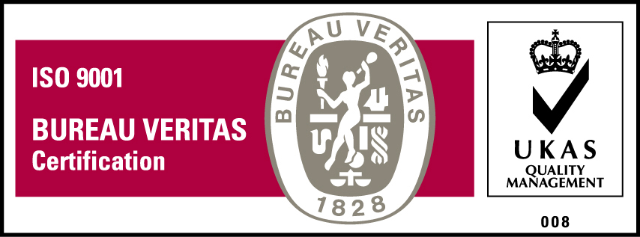***KyU is ISO 9001:2015 Certified***