SINGA Awards for International Students in Singapore, 2019
Agency for Science, Technology & Research (A*STAR), the Nanyang Technological University (NTU), the National University of Singapore (NUS) and the Singapore University of Technology and Design (SUTD)
Application Deadline: June 1, 2018
Apply Now
Full-Time MBA Scholarship Opportunities at Aston Business School in UK, 2018
Aston Business School, United Kingdom
Application Deadline: May 21, 2018
Apply Now
Volkswagen Foundation Freigeist Fellowships for International Researchers in Germany, 2018
Volkswagen Foundation, Germany
Application Deadline: October 12, 2018
Apply Now
Guangxi Government Scholarship for ASEAN Students in China, 2018-2019
Guangxi Government
Application Deadline: June 15, 2018
Apply Now
150 Global MBA Scholarships for Women at University of London in UK, 2018
University of London
Application Deadline: June 1, 2018
Apply Now
Fully Funded Falling Walls Science Fellowship for Journalists/Bloggers in Germany, 2018
Falling Walls
Application Deadline: June 24, 2018
Apply Now
16 New PhD Positions for International Doctoral Students in Austria, 2018-2020
The Austrian Science Fund
Application Deadline: Open for 2018-2020
Apply Now
Fully Funded World Bank ACE II Master Fellowships for Female African Students, 2018
Inter University Council For East Africa
Application Deadline: June 4, 2018
Apply Now
Kingston University International Scholarships in UK, 2018
Kingston University, United Kingdom
Application Deadline: May 31, 2018
Apply Now
University of Queensland International Scholarships in Australia, 2018
University of Queensland, Australia
Application Deadline: June 1, 2018
Apply Now
Master of Law Scholarships at WU Executive Academy in Austria, 2018
WU Executive Academy, Austria
Application Deadline: June 30, 2018
Apply Now
INHA Scholarships for Foreign Researchers in France, 2018
National Institute of Art History, France
Application Deadline: June 15, 2018
Apply Now

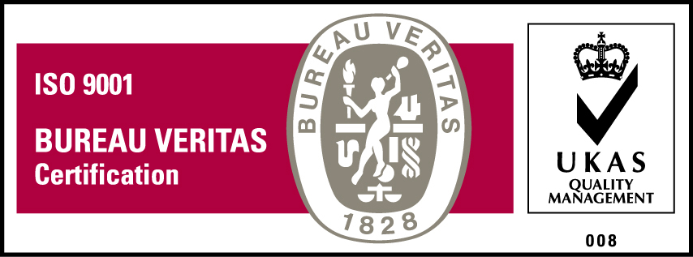
KyU is ISO 9001:2015 Certified

